Carousel Slider

Workshop #01

Flutter Developer Bootcamp

# **Purpose**

This workshop demonstrates how to implement a plugin .A carousel slider is a widget that allows the user to display a series of items horizontally, often with the ability to swipe or navigate through them, much like a carousel or slideshow.By using carousel slider plugins in flutter.

**Problem**

In the given workshop,you need to create 3 additional images and it in vertical format using the same plugin.

**How to Solve**

1. Checkout the workshop from Git Repo:

git clone -b <user-branch> <repo-URL>

2. Open the root folder inside VS Code

3. Execute the code by running command from the root: <full-command>

4. Create 3 additional images vertically mentioned in the problem.

6. Go To File: <specific-file-with-plugin-method> à <method-name>, implement your plugin logic. Make the plugin work

# **You Will Achieve**

When you complete this workshop, you will learn the following:

* **AppBar:** This widget represents the app bar at the top of the screen. It typically contains the title and may include other actions or widgets.
* **Column:** This widget lays out its children vertically, in a column. In this app, it's used to stack multiple widgets vertically, including the CarouselSliders.
* **CarouselSlider:** This widget displays a carousel of widgets, allowing users to swipe horizontally or vertically to navigate between items. It's a part of the carousel_slider package. Each CarouselSlider has its own set of options, like autoPlay, aspectRatio, etc.
* **CarouselOptions:** This class specifies the configuration options for a CarouselSlider, such as whether to enable autoPlay, enlargeCenterPage, aspectRatio, and scrollDirection.
* **Image.network:** This widget loads and displays an image from a network URL. It's used here to display images within the CarouselSlider.
* **FloatingActionButton:** This widget represents a button that floats above the body of the app. In this case, it toggles the auto-play functionality of the CarouselSliders.
* **Icon:** This widget displays a Material Design icon. It's used inside the FloatingActionButton to display an icon indicating the action (start or stop auto-play).
* **setState:** This method belongs to the StatefulWidget class and is used to notify the framework that the internal state of this object has changed. When the state is updated using setState, the UI is rebuilt with the updated state.

# **Screenshots**

## **Before implementation (Images in horizontally)**

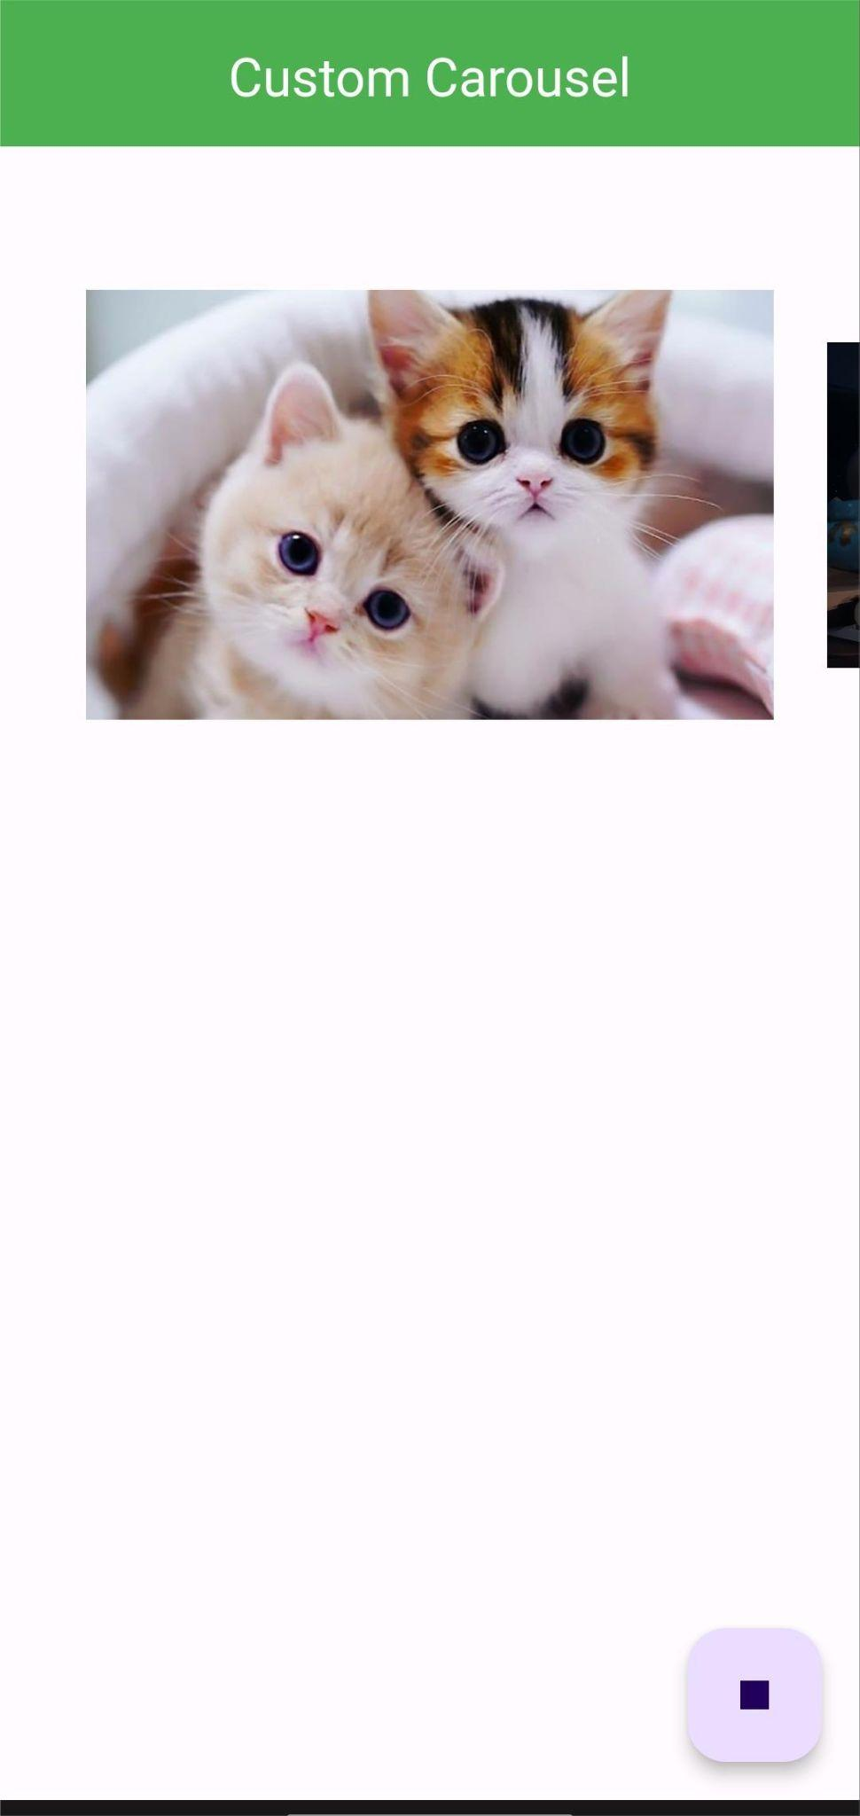

## **After implementation (Images in both horizontally and vertically)**

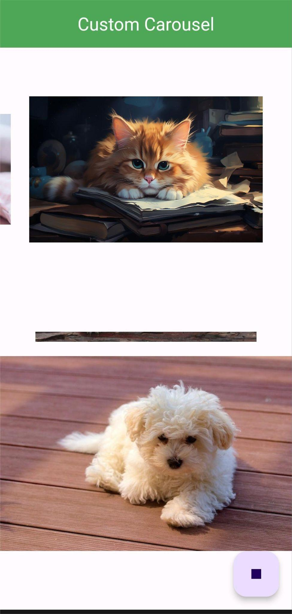

# **How to submit your workshop**

Push your project back to the same git branch using command:

<command name>

# **Happy Coding!**